Exploring Music | Musical Elements Worksheet | Name __________________
Melody:

Range:

Conjunct:

Disjunct:

Scale:

Happy Birthday Melodic Sketch

Example of Musical Notation
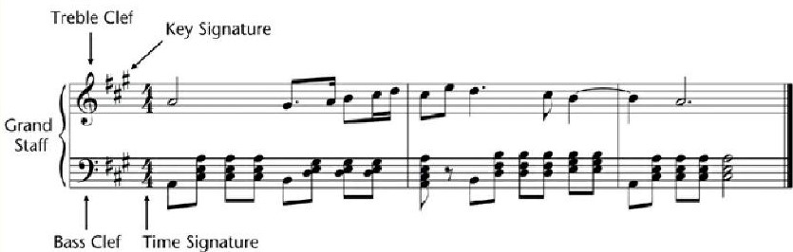

Rhythm:

Beat:

Measure:

Meter (triple and duple):

Tempo:

Kotekan Pattern (Figure 2.8 in textbook)
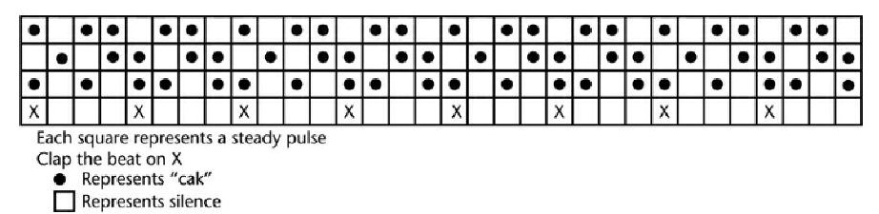

Harmony:

Consonant:

Dissonant:

Chord:
Texture:

Monophony:

Polyphony:

Homophony:

Heterophony:

Biphony:

Dynamics:

Crescendo:

Decrescendo:

Draw how a composer would tell a performer to go from:
sort-of loud to very soft loud to very loud sort-of soft to sort

Timbre:

The most common division of instruments in the West includes:

Hornbostel and Sachs classification system:

Form:

How is form different than genre?

Write down some examples of form:

Write down some examples of popular genres:

Write down some examples of genres used in Western Art Music:

Review Notes/Miscellaneous:

After finishing our week on the musical elements, which areas do you especially want more practice with?

